atitit.提升稳定性框架-----web conn,io log超时机制

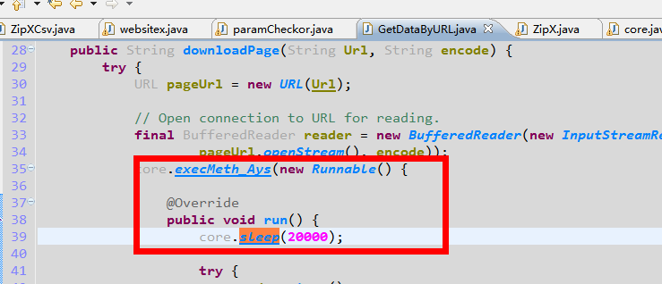todox

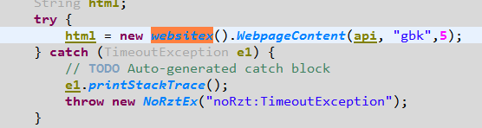
Catch ex throw NorztEx

3. resRealeaseor Pool..

